Dear [Preferred Sponsor],

The Michigan Medical Billers Association (MMBA) is a non-profit organization committed to the education and professional advancement of medical billers, coders, revenue cycle managers, health information management professionals, and business owners across Michigan and beyond. As we are preparing for our 19th Annual MMBA Expo on Thursday, September 17th, 2026, at the Wyndham Hotel & Banquet/Conference Center in Flint, Michigan, we invite you to join us as a valued sponsor.

This premier event offers a unique platform for networking and engagement, bringing together over 190 MMBA members across Michigan with members from cities like Detroit, Lansing, Saginaw, Grand Rapids, and Traverse City and other attendees from across Michigan and beyond. The Expo fosters valuable connections between sponsors and medical billing professionals, creating an environment where all participants benefit from meaningful interactions.

As a sponsor, you’ll have exclusive opportunities to connect directly with industry professionals, introduce your products and services, and gain significant brand exposure throughout the event, including during breaks and lunch sessions. This is an exceptional chance to expand your reach and build lasting relationships within the healthcare revenue cycle community.

Enclosed, you’ll find detailed information on sponsorship opportunities and benefits. We are confident that your participation in the 2026 MMBA Expo will not only enhance your business visibility but also contribute to the overall success of this event. Our attendees are excited about meeting and learning about you and your services!

If you are interested in becoming a sponsor or have any questions, please feel free to contact me at 517-230-9491 Youngmedconsult@gmail.com I look forward to the opportunity to collaborate and appreciate your support in advancing medical revenue cycle education and professional development.

Thank you for considering this opportunity, and we hope to welcome you as a sponsor at MMBA’s 2026 Expo!

Warm Regards,

Jill

Jill Young, CEMC, CPC, CEDC, CIMC
Director of Special Events, MMBA
Cell: 517-230-9491
Youngmedconsult@gmail.com

Nineteenth Annual MMBA Expo - September 17th, 2026
Sponsorship, Representative Contact, and Payment Form
We apply for booth space at the Wyndham Hotel & Banquet/Conference Center in Flint, MI and agree to the Sponsorship/Event Guidelines. Upon MMBA’s acceptance, this application becomes a binding contract. Booths are assigned on a first-come, first-served basis per the guidelines. Payment is due by July 31, 2026, to be included in the Expo Brochure. (Hotel room block code 091626MMB_001)
Company Name:
Description of Business:
Mailing Address:
City/State/Zip:
Phone: | Email:
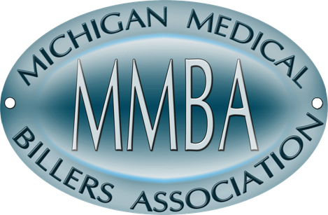
Contact Person to Receive Booth Info:
Select Preferred Sponsorship Level:
□ Gold $750 | □ Silver $600 | □ Bronze $450
(SEE SPONSOR BENEFITS LISTED ON THIS FORM FOR DETAILS)
Select Additional Sponsorships:
□ Chapter Gift Basket  (TWO Sponsorships Available) | $250 | - Merch/swag/info (ordered/provided by sponsor) put into gift baskets  - Recognition from podium during gift drawing
□ Expo Brochure - Logos Galore  (TWO Sponsorships Available) | $600 | - Full-page ad in Expo Brochure  - Recognition in pre-event email promotions  - Logo placement on Expo Schedule page
□ Premier Networking Breakfast  (ONE Exclusive Sponsorship Available) | $750 | - Exclusive signage at the breakfast area  - Opportunity to place branded materials at each seat  - Recognition in event announcements and social media
□ Energizer Snack Break  (ONE Exclusive Sponsorship Available) | $750 | - Custom signage at snack stations  - Logo placement on snack grab bags (if applicable)  - Additional shoutout in the event program and social media
□ Signature Lunch  (ONE Exclusive Sponsorship Available) | $1,000 | - Logo placement on all lunch tables and buffet signage  - Recognition from the podium during lunch  - Branded napkins or placemats (ordered/provided by sponsor)
□ Exclusive Name Badge & Lanyard  (ONE Exclusive Sponsorship Available) | $1,000 | - Logo prominently featured on attendee name badges  - Branded lanyards provided to all attendees (ordered/provided by sponsor)  - Sponsor mention in ALL event communications
1/4 Page Ad in Expo Brochure ONLY:
□ Pre-Event $250 | □ Promotion Sponsorship $250
Included in Sponsorship Payment: Six-Foot Table, Six-Foot Booth Space, and Electrical Hook-up (if needed)
(Booth space is a 6ft table. An additional 6ft booth space may possibly be purchased for $100 if available)
CHECK THIS BOX IF ELECTRICAL HOOK-UP IS NEEDED - □
(All Telecommunication and shipping needs must be arranged and paid for in advance with the Wyndham Hotel)
Booth Representative info: (Two reps included: Additional rep(s) are $75.00, per rep)
Name: | Email:
Name: | Email:
(Add)Name: | (Add) Email:

TOTAL AMOUNT DUE: | Payment Method: □ Check/Money Order □ Credit Card
Payment Instructions:
By Mail | Print completed form and send with a RECEIPT OR CHECK made payable to: “MMBA”  Send to – “Michigan Medical Billers Association”, PO Box 4031, Lansing, MI 48826
By Credit Card: | Email completed form to info@mmbaonline.org and call 855-360-3401.

MMBA Preferred Sponsorship Benefits
Sponsor Level | Cost | Benefits
Gold | $750 | - Premium placement of table/booth (Limit 2 booth reps with meals included)  - Copy of attendee roster (emails)  - Sign with logo displayed near the registration table  - Full page acknowledgement in on-site brochure  - Special thanks in our online newsletter (to include link to your website)  - Plus, all benefits of the Pre-promotion Sponsorship
Silver | $600 | - Table/Booth (Limit 2 booth reps with meals included)  - Sign with logo displayed near the registration table  - Half page acknowledgement in on-site brochure  - Special thanks in our online newsletter (to include link to your website)  - Plus, all benefits of the Pre-promotion Sponsorship
Bronze | $450 | - Table/Booth (Limit 2 for booth reps with meals included)  - Quarter Page acknowledgement in on-site brochure  - Plus, all benefits of the Pre-promotion Sponsorship
Pre-Promotion | $250 | - Pre-event promotion via Social Media and member emails  - Your logo as part of the slides that is displayed prior to the start of the Expo  - An introduction of you as our sponsor at the beginning of the Expo
Other | Varies | - See page 4 for details.
Sponsorship/Vendor/Event Guidelines
- Sponsors/Vendors may not solicit MMBA members at the conference without the MMBA Board's permission. Becoming a sponsor (Preferred or Event) assures this permission. Vendors who solicit MMBA members at conferences, hospitality suites, etc., without the MMBA Board's permission may be excluded from participating in future conferences.
- The vendor is hereby given the right to cancel this agreement without penalty at or any time prior to 90 days in advance of the MMBA meeting, such cancellation to be effective when written notice thereof is received by the MMBA Admin Assistant, Lansing, MI. A $75.00 administration fee will be assessed on any refunds. After the 90-day period, no refunds will be issued. All accounts must be settled within this time.
- The vendor assumes the entire responsibility of liability for losses, damages, claims of injury or damage to the vendor and its representatives, displays, equipment, and any property brought onto the premises of the host facility and shall indemnify, hold harmless, and release MMBA and the host facility agents, servants, and employees from any liability entirely for such losses, damages, and claims.
- Vendors may not bring more than two representatives to the conference unless meals are purchased with submission of this application for the third/additional representative(s). Meals are $75.00 per additional representative.

- In order to potentially have your company listed in the on-site program and on signs where appropriate, this application including payment MUST BE POSTMARKED July 31st, 2026. Applications postmarked after July 31st, 2026 may not be included in these listings.

- Dates and Times for the September 17th, 2026, MMBA Expo are as follows: September 16th - Booth set up evening (TBA) Main Ballroom
September 17th - Booth set up 6:30am - 7:00am Main Ballroom
September 17th - Conference 7:00am - 4:00pm

* We ask that all vendors be set up no later than 7:00am on September 17th, 2026, and have at least one representative at their booth during the non-session times. Please do not leave until the last session is in progress starting at 3:00pm.
Thank you!
REGISTER YOUR PRIZE DRAWING
FOR THE 2026 MMBA EXPO!

Here’s how it works:

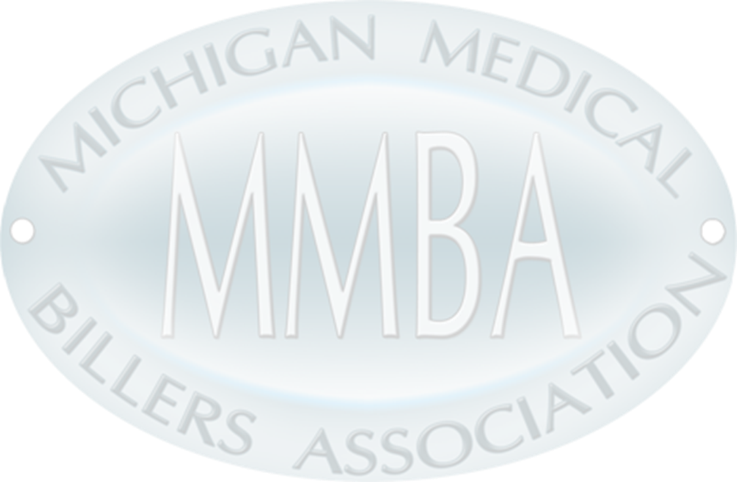
- Bring a prize to the conference with your business card securely attached.
- Display the prize at your booth.
- Collect business cards/drawing slips from the attendees*
- Draw the winning card/drawing slips.
- A Member of the MMBA Board will collect your winners’ name after the last break. A rep will need to be at your booth for us to collect this information, or we will draw your
winner’s name and notify you of the results.
- The MMBA Board will present the prizes at the end of the conference.

If you have a Prize Drawing, please return this form with the following information:

Company Name:

Contact Person:

Prize (or Prizes):

*Please note: It is imperative that vendors come prepared with means to collect entries for the drawing. MMBA will not facilitate this for vendors.
Also, know that not all attendees may have business cards. Thank you!

